[leave this line empty]
[leave this line empty]
Article Category [Choose one: Research Article, Case Study, Literature Review, Technical Note]
[leave this line empty]
The manuscript title submitted to journal of sustainable decisions intelligence and optimization (sentence case text)
[leave this line empty]
Author-a ^{1,✴}, Author-b ², Author-c ^{n}
[leave this line empty]
¹ Department of Industrial Engineering, ZZZ University, City, COUNTRY
² Department of Computer Science, AAA University, City, COUNTRY
³ School of XXX, YYY University, City, COUNTRY
etc.
✴email: xyz@uin.ac.sg [email of corresponding author]
[leave this line empty]
[leave this line empty]
ABSTRACT
[leave this line empty]
[Start your Abstract here, single-paragraph of 250-300 words] ………………

Guidelines:
ABSTRACT: The powerful standalone summary
- Structure: Briefly state
  - Background/rationale: Why does the study matters? And what problem does it address?
  - Methods: What core methods were used?
  - Results: What are the most important and impactful findings? Include key quantitative data (if important).
  - Conclusion/implications: What are the main conclusions and their broader significance?
- Be comprehensive yet concise: Adhere to the word limit (typically 250 – 300 words).
- Highlight novelty and significance: Make it clear what is new and important about your work.
- Write it last (often useful): Ensure it accurately reflects the full paper.
- Use keywords: Mirror those in the title and add others if relevant (4-5 keywords allowed).
[leave this line empty]
Keywords: for example, performance measurement, lean manufacturing, production efficiency, artificial intelligence
[leave this line empty]
[leave this line empty]
[leave this line empty]
[leave this line empty]
INTRODUCTION [12 pt]
[leave this line empty]
Start the section here [10 pt] …………

Guidelines: Setting the stage for impact (Min. 1200 words length)
Please ensure that all the aspects listed below are included. The sequence of the content does not need to be strictly followed, as long as all elements are clearly addressed.
- Start by situating your research within a larger field of study. Explain why this general area is important.
- Set the focus area where your research is situated. Provide evidence from the literatures.
- Demonstrate your mastery of the field. Show how your work builds upon or challenge existing knowledge. Do not just summarize what have been done in the relevant studies, but synthesize and critique.
- Clearly articulate the specific unanswered question, or unsolved problem, that your research addresses.
- Convincingly argue why this gap needs to be filled now. Highlight the potential benefit of addressing it.
- Explicitly state what the study aimed to achieve or investigate.
- Give a roadmap of how you tackled the problem (optional, but often helpful).

Tips:
- Organize the Introduction into clear thematic presentation based on key aspects above, and use transitional sentences for smoother progression;
- Use a “funnel” structure, starting broad and narrowing down to your specific research problem/question; Convince the reader why this study was necessary.
- For research initiated by a practical case problem, the case description should not dominate the introduction section as the central theme. Instead, the introduction section must position the case within its broader scientific context, using the case as a motivating example to justify the relevance and significance of the research. This framing should be followed by a clear articulation of key criteria in the above Introduction’s guidelines. Detailed descriptions of the case—such as operational characteristics, contextual factors, or technical constraints—should be appropriately presented in the Methods or Results and Discussion sections, depending on the structure and flow of the manuscript.

In-text-citations:
Use IEEE citation style consistently throughout the manuscript.

For Example:
At the beginning of the sentence:
“Smith [4] and Brown and Jones [5] explained ….“
“Several recent studies [3], [4], [15], [22] suggested that ….”

Use “et al.” when three or more names are given for a reference cited in the text.
“Wood et al. [7] investigated ….“

At the end of the sentence:
“ …. increase the efficiency of the supply chain system [13], [14], [17]-[20].”
“ …., as in [8].”

METHODS [12 pt]
[leave this line empty]
Start the section here [10 pt] …………

Guidelines: The foundation of credibility and future use
- Describe your methods so that another competent researcher in your field could reproduce your study in the future. Be precise about materials, procedures, equipment, and data analysis technique.
- Explain why specific methods are chosen, especially if they are novel or less common. Justify their suitability for answering the research question/problem.
- If your methodology is novel, or a significant improvement, make this clear.
- Clearly state that ethical approvals were obtained, and describe how ethical guidelines were followed (e.g., informed consent, etc.).
- Details all statistical tests (if used), and the criteria for significance.
- Indicate where data and code (if applicable) can be accessed, promoting transparency and reusability.

For Research on LITERATURE REVIEW category

The METHODS section should include the following key elements:
Protocol and Framework:
- A recognized framework is referenced and adhered to.
- The review protocol, either as pre-registered or described in detail within the manuscript.
- Inclusion and exclusion criteria defined to establish the scope and boundaries of the review..
Search Strategy:
- Databases and sources (e.g., Scopus, Google scholar, Web of Science, etc.).
- Search terms and/or Boolean operators.
- The search strategy.
Study Selection Process:
- The screening process, including tools or software used (e.g., Covidence, EndNote, etc.).
- A flow diagram (e.g., PRISMA) or equivalent to visualize the selection process.
- Measures to minimize bias, such as independent reviewers and conflict resolution procedures
Data Extraction and Synthesis:
- A clear, structured data extraction form or table.
- Key variables extracted (e.g., study design, population, outcomes)
- The synthesis method (e.g., meta-analysis, thematic analysis, etc.)

Additional Headings:

When necessary, additional headings can be created using the format below:

Second-level Heading [12 pt, bold]
….

Third-level Heading [11 pt, bold and italic]
….

Fourth-level Heading [11 pt, italic]
….

For additional lower-level headings, use an itemized format with bullets and/or numbering [10 pt].
- …..
- …..
- …..

Tables:
- The Table uses no vertical lines.
- All text in the table is top-left alignment.

Use the following table format (DO NOT change spaces, cell margin and other setting, except the number of column and column width)

Table 1. First Example (Basic format, using first-level column head)
Column Title 1 | Column Title 2 | Column Title n
The description; in single line | The description | …..
The description - For long description, design more-left indentation starting for line 2. | The description - For long single description, design more-left indentation starting for line 2. | …..
The description | The description | …..
The description | The description | …..

Table 2. Second Example (Using second-level column head)
Column Title 1 |  |  | Column Title 2 | Column Title n
Sub-title 1 | Sub-title 2 | Sub-title m | Column Title 2 | Column Title n
….. | ….. | ….. | ….. | …..
….. | ….. | ….. | ….. | …..
….. | ….. | ….. | ….. | …..

Table 3. Third Example (with third-level column head)
Column Title 1 | Column Title 1 |  | Column Title n
Column Title 1 | Sub-title 1 | Sub-title m | Sub-title 1 |  | Sub-title m
Column Title 1 | Sub-title 1 | Sub-title m | 2nd Sub-title 1 | 2nd Sub-title k | Sub-title m
….. | ….. | ….. | ….. | ….. | …..
….. | ….. | ….. | ….. | ….. | …..
….. | ….. | ….. | ….. | ….. | …..

Figure:
The figure should be kept as small as possible while ensuring that all required information is properly presented, with clear-resolution and readability. The figure, along with its caption, should be center-aligned.

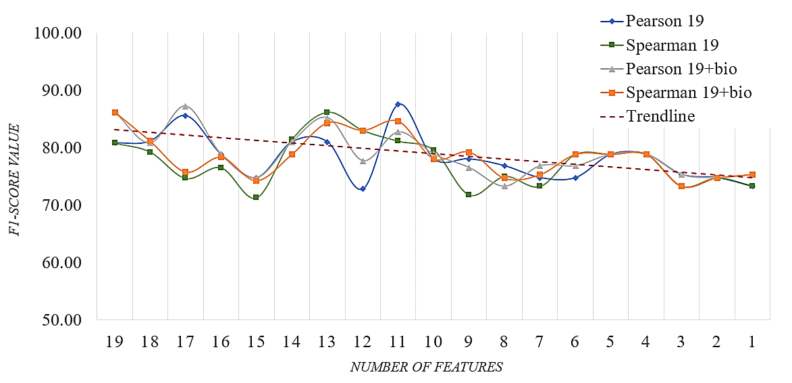

Figure 2. Example of Figure

Equation:
The equation expression should be left-alignment with equation number is of right-alignment. For convenience, write equation inside two-column table. Once finished, make the table line invisible.

For short (single line) equation:

$A=πr^{2}$ | (1)

For long equation, design more-left indentation starting for line 2:

$$A=$$ | $πr^{2}+πr^{2}+πr^{2}+πr^{2}+πr^{2}+πr^{2}+πr^{2}+πr^{2}+πr^{2}+πr^{2}+πr^{2}+πr^{2}+πr^{2}+πr^{2}+πr^{2}$ | (2)
 | $+ πr^{2}+πr^{2}$

RESULT AND DISCUSSION [12 pt]
[leave this line empty]
Start the section here [10 pt] …………

Guidelines: Presenting on evidence clearly and objectively; Focusing on Interpretation, implication and advancement.
- Structure this section to align with your research problem / question or hypotheses.
- Report what you found. Draw attention to the main results, often with statistics summary when appropriate. Avoid presenting step-by-step computational output. Instead, locate them in Appendix (if necessary). A maximum four-page appendix allowed.
- Employ high-quality figures (graphs, charts, image) and tables to present data effectively. Ensure they are all well-labelled, easy to understand, and self-contained.
- Honest reporting of all relevant findings, even those that don’t support hypotheses, is crucial for scientific integrity.
- Ensure all data in the text match data in tables/figures.
- Explain your main findings e.g., what they mean in the context of your research problem and the existing literatures.
- Compare and contrast with previous works (if relevant). Discuss how your findings align with or differ from previous studies. Explain any discrepancies.
- Reiterate what is new and important about your work.
- Discuss any limitations of your study (e.g., methodological constraints, sample size, generalizability). This shows critical self-awareness.
- Discuss broader implications (theoretical, practical, or policy implications) of the findings. Explain how the study advances the field.
- Avoid over-interpretation or speculation. Ensure your interpretation are well-supported by your data.

For Research on LITERATURE REVIEW category
The RESULTS AND DICUSSION section should include the following key elements:
- Identification of key themes, patterns, and gaps in the literature; Categorize and synthesize the findings logically.
- Evaluation on the quality and limitations of the included studies, including potential biases (e.g., publication bias, selection bias, etc.)
- The discussion on the limitations of the review itself and strategies to address them.
- The discussion that links results to the research question and identified implications for theory, practice, or policy.

CONCLUSION [12 pt
[leave this line empty]
Start the section here (max. two paragraphs) [10 pt] ……………

The final powerful statement
- Provide a brief summary of your main conclusions (in line with research objectives) and their most important implications (avoid presenting detailed numerical result).
- State the most important thing about your research you want the readers to remember.
- Avoid introducing new information or speculation: Stick to what your study has demonstrated.

AKNOWLEDGEMENTS [12 pt] – (Mandatory in Submission stage)

………………….

DECLARATION OF AI USE [12 pt] – (Optional in Submission stage)

In addition to plagiarism screening, the JSDIO editorial team also conducts AI-usage detection using Turnitin software.
If a manuscript is confirmed to have used generative AI tools for copywriting (e.g., creating, drafting, or composing any part of the submission), the author(s) will be notified and given the opportunity to revise the manuscript to ensure that AI-generated content is no longer detectable.
However, if AI tools are used for copyediting (e.g., correcting, editing, formatting, modifying, or refining the author’s original work to enhance structural coherence, linguistic clarity, and grammatical accuracy), a formal declaration of AI usage is required and must be stated in this section. This declaration is mandatory only in such cases and will be published alongside the article to maintain transparency.

Find more information about our AI Usage policy at https://jsdio.org/index.php/journal/ai-usage

…. [10 pt]

CONFLICT OF INTERESTS [12 pt] – (Mandatory in Submission stage)

…. [10 pt]

FUNDING [12 pt] – (Mandatory in Submission stage)

…. [10 pt]

- If the research received specific financial support:

"The author(s) disclosed receipt of the following financial support for the research, authorship, and/or publication of this article: This work was supported by the [Name of Funding Agency Council] [grant number: XXXX]; and [Name of Other Funding Agency] [grant number: YYYY]."

- If no specific funding was received for the research, authorship, and/or publication, the statement should be written as:

"The author(s) received no financial support for the research, authorship, and/or publication of this article."

DATA AVAILABILITY STATEMENT [12 pt] – (Mandatory in Submission stage)

…. [10 pt]
See “A. Data Availability and Sharing” on https://jsdio.org/index.php/journal/data-sharing-reproducibility

References [12 pt]

Use IEEE reference format consistently. Ensure to include any DOI (when applicable) ….. [10 pt]

APPENDIX [12 pt] – (As required)

…… [if any] [10 pt]

AUTHORS BIOGRAPHY [12 pt] – (Mandatory in Submission stage)

Max. 75 words biography for each named author

….. [10 pt]

